Beth - Wood Baseball League
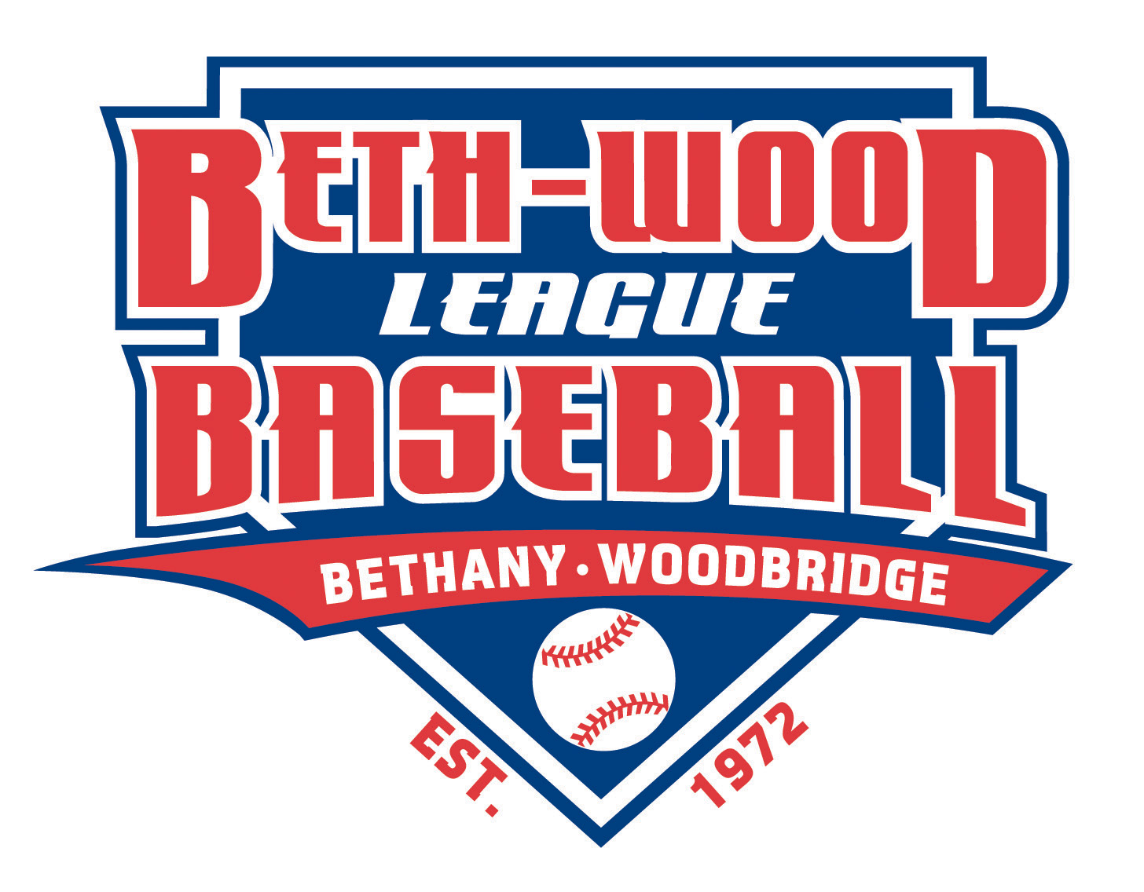

BETH – WOOD BASEBALL LEAGUE
2020 PLAYERS CLINIC
Beth - Wood Rookies, Minors & Majors :
Head Baseball Coach Sal Coppola and his staff of the State Champion Amity HS Spartans will once again be hosting their annual Players Clinic for our Players ages 7 - 12 (Rookies - Majors) on Tuesday evening, March 3RD, at Amity HS at the following times :
Players (ages 7 - 9) has their Clinic from 6:00 - 7:00 PM : If you are interested in attending, please contact Rookies Commissioner Kane D’Amico at kanedamico@gmail.com to reserve your spot
Players (ages 10 - 12) has their Clinic from 7:30 - 9:00 PM : If you are interested in attending, please contact Minors Commissioner Mark Grogan at mgrogan@gmail.com
This always has been a great Clinic that Coach Sal puts on every year for our children, as they will learn from one of the best High School Coaches in the State - you don’t want to miss it, so please contact either Kane and / or Mark ASAP to reserve a spot for your children. Hope to see you all there !!
Beth - Wood Baseball Board {bethwoodbaseball@gmail.com}

